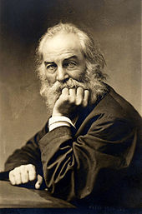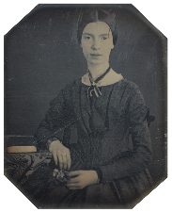American Poetry Masters Webquest

Emily Dickinson and Walt Whitman

Emily Dickinson and Walt Whitman are considered the parents of American poetry. Positioned just after the American Renaissance and discussed before The Rise of Realism that reflected the Civil War, both poets have served as models for twentieth century poets. People have been drawn to each specific style and technique each author has mastered. It is their differences in literary style, subject matter, attitudes towards life, family, and personal lifestyles that are vastly different. Although their style and literature is uniquely different from each other, they both add similar literary quality to this period in literature.

Directions: For this assignment, you will be researching the poets’ lives in order to learn a little bit more about why and how they wrote. Please use the links provided as they have been reviewed for content and accuracy.

**Emily Dickinson**

<http://www.poets.org/poet.php/prmPID/155>

<http://www.ushistory.org/us/26c.asp>

1. List birth and death dates
2. List three interesting facts about Dickinson’s life from the biography page.
3. List two ideas in or characteristics of her poetry.
4. When did Dickinson die? What was found after her death?
5. Why do you think Dickinson never published her poems? Support your answer with evidence from the article.
6. What was the role of women in the 1800s to pre-civil war in America?
7. How did the women’s suffrage movement change American women?

**Walt Whitman**

<http://www.poets.org/poet.php/prmPID/126>

<http://www.loc.gov/teachers/lyrical/poems/my_captain.html>

1. List birth and death dates
2. List three interesting facts about Whitman’s life from the biography page.
3. What kinds of jobs did Whitman work?
4. What was the title of his first book with twelve untitled poems and a preface? What year was it published? What happened after it was published?
5. Describe the relationship between Walt Whitman and Abraham Lincoln.
6. What poem did Whitman write to in reaction to Lincoln’s death.

Reflection Question: Both poets are considered two of the most important in American literature. To which poet might you best relate? Why?